logo_ryerson

Department of Electrical & Computer Engineering

Programs: Electrical & Computer Engineering

|  |  |
| --- | --- |
| Course Number | **ELE635** |
| Course Title | **Communication Systems** |
| Semester/Year | **Winter 2019** |
| Instructor | **Ngok-Wah Ma** |

|  |  |
| --- | --- |
| **Lab Report No.** | **3** |

|  |  |
| --- | --- |
| Report Title | **Experiment 3: Frequency Modulation and Demodulation** |

|  |  |
| --- | --- |
| Section No. | **10** |
| Group No. |  |
| Submission Date | **March 26th, 2019** |
| Lab Performed Date | **March 26th, 2019** |

|  |  |  |
| --- | --- | --- |
| Name | Student ID | Signature\* |
| Ahmad Ghiasi | *Xxxx80809* |  |
| Vatsal Shreekant | *Xxxx71363* |  |

(Note: remove the first 4 digits from your student ID)

*\*By signing above you attest that you have contributed to this submission and confirm that all work you have contributed to this submission is your own work. Any suspicion of copying or plagiarism in this work will result in an investigation of Academic Misconduct and may result in a “0” on the work, an “F” in the course, or possibly more severe penalties, as well as a Disciplinary Notice on your academic record under the Student Code of Academic Conduct, which can be found online at:*

[*www.ryerson.ca/senate/current/pol60.pdf*](http://www.ryerson.ca/senate/current/pol60.pdf)*.*

# **Introduction:**

Through this experiment a nonlinear modulation technique where the modulating signal varies the instantaneous frequency of the carrier wave, Frequency Modulation, was studied, observed and analyzed. Through the lab various methods for estimating the bandwidth of a Single-Tone Modulated FM signals, for both the Narrowband as well as the Wideband FM signals, was also studied. The methods included Carson’s rule, 1% rule and Universal curve corresponding to the 1-% rule. The effects of lock and pull-in range were also observed. Through the lab many other topics were touched on such as the modulation index and frequency sensitivity parameter, the rms values of the FM signal, the bandwidth of the FM signals, the phenomenon of few narrow band frequency positions being produced when the input frequency was increased towards the negative pull-in frequency range.

# **Theory:**

There are many formulas retrieved from the appendix in order to calculate the modulation index in various ways and there are also formulae used to calculate modulation index, frequency sensitivity parameter and the bandwidth of the FM signal. The main theory behind this lab is the frequency modulation and demodulation of signals using different techniques. Some techniques lie in the time domain where others are in the frequency domain. The operational properties of a Phase Locked Loop were used to demodulate the signals. Finally, the power of the $φ_{FM}\left(t\right)$ is contained within a finite bandwidth. Below are the formulae used throughout the experiment.

The FM signal for a single tone modulating signal $m\left(t\right)=A_{m}cosω_{m}t$ would have the equation as:

$φ_{FM}(t)=A_{c}cos⁡(ω_{c}t+K_{f}\int_{0}^{t}{m\left(λ\right)dλ}=A_{c}cos⁡(ω_{c}t+βsinω_{m}t)$ (Eq.1)

Where $∆ f=K_{f}A_{m}/(2π)$, is the frequency deviation parameter and β is the modulation index of the FM signal.

$β= ∆f/f_{m}$ (Eq.2)

Upon expanding the Real part of the FM signal, the equation now becomes $Re\{A_{c}e^{jβsinω_{m}t}e^{jω_{c}t}\}$. It is seen that the complex exponential $e^{jβsinω_{m}t}$ is periodic and thus expands into the Fourier series:

$e^{jβsinω_{m}t}=\sum_{n=-∞}^{∞}{C_{n}e^{jnω_{m}t}}$ (Eq.3)

$C_{n}=\frac{ω_{m}}{2π}\int_{-π/ω_{m}}^{π/ω_{m}}{e^{jβsinω_{m}t}}e^{-jnω_{m}t}dt=J_{n}(β)$ (Eq.4)

where, $J_{n}(β)$ is the Bessel function of the 1st kind, order n and argument β. Implementing equation Eq.3 and Eq.4, $φ_{FM}(t)$ can be expressed as:

$φ_{FM}\left(t\right)=\sum_{n}^{1}{J_{n}\left(β\right)cos⁡(ω_{c}+nω_{m})t}$ (Eq.5)

Subsequently, since the function is now in a suitable form to compute the spectrum, the equation for the former is as follows:

$Φ_{FM}\left(f\right)=\frac{A_{c}}{2}\sum_{n}^{1}{J_{n}\left(β\right)[δ\left(f-\left(f_{c}+nf_{m}\right)\right)+δ\left(f+\left(f_{c}+nf_{m}\right)\right)}]$ (Eq.6)

It is to be noted that since the modulation index β determines Jn(β), this then determines the shape of the ΦFM(f). This leads to the following observations:

1. Magnitude of the spectral component at fc+nfm is Ac|Jn(β)|/2
2. |Jn(β)| decreases with increasing β (assuming n is fixed).
3. |Jn(β)| decreases with increasing n (assuming β is fixed).

For a Narrowband FM with β ≤ 0.3, the equation for the $φ_{FM}\left(t\right)$ becomes:

$φ_{FM}\left(t\right)≈ A_{c}cosω_{c}t+ A_{c}J_{1}\left(β\right)cos(ω_{c}+ω_{m})t+ A_{c}J_{-1}\left(β\right)cos(ω_{c}-ω_{m})t$ (Eq.7)

Therefore, the bandwidth is as follows:

$B_{FM}≈ 2f_{m}$ (Eq.8)

For a Wideband FM with β ≤ 0.3, the determination of the bandwidth is dependent upon the number of significant sidebands. Using the 1-% rule, the sideband index *n* is determined such as:

$A_{c}\left|J_{n}\left(β\right)\right|> {10}^{-2}A_{c}J_{0}(0)$ (Eq.9)

With nmax being the largest value of the sideband index and $\left|J_{n}\left(β\right)\right|> {10}^{-2}$, the nmax is determined from a table of values of Bessel function. With nmax determined, bandwidth is then estimated as:

$B_{FM}≈ 2{n_{max}f}_{m}$ (Eq.10)

Subsequently, the x-% rule can also be applied by implementing the Universal Curve. This is done by normalizing the results derived from the Bessel function tables with respect to the frequency deviation $∆f$ and then plotting it as a function of $β$. The bandwidth *B*FM is then estimated using the modulation index $β$ and the frequency deviation $∆f$ parameters.

**Procedure:**

### Part A: Characteristics of FM Signals

1. The modulating signal was connected to Channel 1 and the FM signal was connected to Channel 2 of the oscilloscope. The setting described in Part-A/B Setup were used and the modulating and FM signals were displayed. The one-sided rms spectrum of the FM signal was displayed on the oscilloscope using the modulating signal as the trigger.
2. The amplitude of the modulating signal was increased from 2 Vpp to 10 Vpp and the corresponding changes in the spectrum of the FM signal were observed.
3. The amplitude was reset to 2 Vpp and the frequency of the modulating signal was gradually reduced from 1 KHz to 100 Hz and the corresponding changes in the spectrum of the FM signal were observed.
4. The amplitude and the frequency were then set to 2 Vpp and 1 kHz respectively. The resulting one-sided rms values of the spectrum were recorded. The parameters of the modulating signal were then changed to 1 Vpp and 500 Hz. Similarly, the resulting one-sided rms values of the spectrum were recorded.

### Part B: Modulation Index

1. The parameters of the modulating signal were set to roughly 0 V and 1 kHz. The amplitude was then gradually increased until a spectral null at carrier frequency 10 kHz was observed. The corresponding values of the amplitudes of the modulating signal were recorded and the modulation index $β$ and the frequency sensitivity parameter $K_{f}$ and were determined.
2. The amplitude of the modulating signal was increased until a second spectral null was spotted at the carrier frequency. The corresponding values of the amplitudes of the modulating signal were recorded and the modulation index $β$ and the frequency sensitivity parameter $K_{f}$ and were determined.
3. The frequency of the modulating signal was set at 1 kHz and the frequency sensitivity parameter $K_{f}=3.45 kHz/V$ and the value of the amplitude of the modulating signal was calculated to achieve the modulation index $β=0.2, 1 \& 5.$
4. With the modulating signal amplitude at the recorded value, the modulation index $β=0.2$ was achieved. The magnitudes of several spectral components of one sided rms spectrum were measured and recorded, ignoring the spectral components with magnitude less than 10 mV.
5. Step 4 was repeated for modulation index $β=1 \& 5.$

### Part C: Operational Characteristics of Phase Locked Loop

1. The connections were setup based on the instructions and the free running of the VCO was set to 10 kHz. The DMM was used to measure the DC voltage Ve. The measured voltage was labelled as Vref and represented the VCO input when the PLL entered the free-running mode.
2. FG1 was reconnected to the terminal of the PLL and as adjusted to generate $v_{i}\left(t\right)= A_{i}cos2πf_{i}t$ with *fi* = 4 kHz and *Ai* = 2 Vpp. Channel 1 was connected to vi(t) and channel 2 was connected to vo(t). With vi(t) as the trigger source, the traces synchronized when the PLL was in lock condition.

The input frequency *fi* was gradually increased and the *f-p* frequency was determined at which the traces synchronized. The *f-p* defined the lower edge of the of the pull-in range of the PLL. With the PLL in locked condition, the DC voltage *Ve* was measured at the DEMout terminal of the PLL module.

1. The input frequency *fi* ­was increased in 1 kHz increments. As the PLL was in locked condition, for each measure of *fi* the DC value ve and phase angle vo(t) with respect to vi(t) was calculated. The frequency at which the PLL could no longer track, *fi* was recorded. The upper edge of the lock range was defined by *fL+*.
2. The *fi* was set at 16 kHz, which was then gradually decreased and the *fp+* was determined when vi(t) and vo(t) synchronized. With the *fc+* being defined as the upper range of the pull-in range of PLL, *fi* was decreased in 1 kHz decrements. As the PLL was in locked condition, for each measure of *fi* the DC value ve and phase angle vo(t) with respect to vi(t) was calculated. The frequency at which the PLL could no longer track, *fi* was recorded. The lower edge of the lock range was defined by *fL-*.

### Part D: Demodulation of FM Signals

1. This was a step that was asked of us not to perform due to lack of equipment and information provided during the lab session, hence the TA asked us to skip this bit. The instructions, however, went as follows. Since the lowpass filter module smoothed out the demodulated signal ve(t), the -3db frequency of the lowpass filter was set at 1 kHz.
2. With the connection made as per the instructions in the lab manual the FG1 was adjusted to output a single tone modulating signal with frequency 100 Hz and amplitude 2 Vpp.

The FG2 was adjusted to generate an FM signal with amplitude 2 Vpp and carrier frequency 10 kHz. The free running frequency of the VCO was set to 10 kHz and the modulating signal and the lowpass filtered demodulated signal were displayed on the oscilloscope. Channel 2 was then switched to AC-coupled mode and the frequency of the modulating signal was changed to verify that the PLL could successfully extract the modulating signal from the FM signal.

1. The system was then reconfigured as per the instructions in the lab manual. The modulating signal on the Simulink scope and the filtered demodulated signal were observed. The success of the PLL in demodulating the FM signal was the verified.
2. The FM signal was to be connected to the oscilloscope and the spectrum was to be displayed. After changing the span, center and v rms parameters of the spectrum analyzer, the dynamic structure of ΦFM(f) and how the FM signal bandwidth changed as a function of the amplitude of the audio signal was observed.

# **List of Instruments**

* Agilent DSO-X 2002A digital storage oscilloscope with waveform generations and spectrum analyzer options
* GW Instek GFG-8216A function generator
* Hewlett Packard 33120A function/arbitrary waveform generator
* PLL module based on LM565C chip
* Lowpass filter module
* Agilent E3603A triple output DC power supply
* Computer with Linux operating system
* MATLAB/Simulink 2014B

**Observation:**

Part A: Characteristics of FM Signals

The oscilloscope’s spectrum and time analysis of the FM signal, $ϕ_{FM}\left(t\right),$ when $m\left(t\right)$ is increased from **2 V** to **10 V** is shown in **Figure 1**. It was obvious that this results in a spectral null in the middle of the signal. Furthermore, by increasing the amplitude of $m\left(t\right)$ increases the Bandwidth of the spectrum.

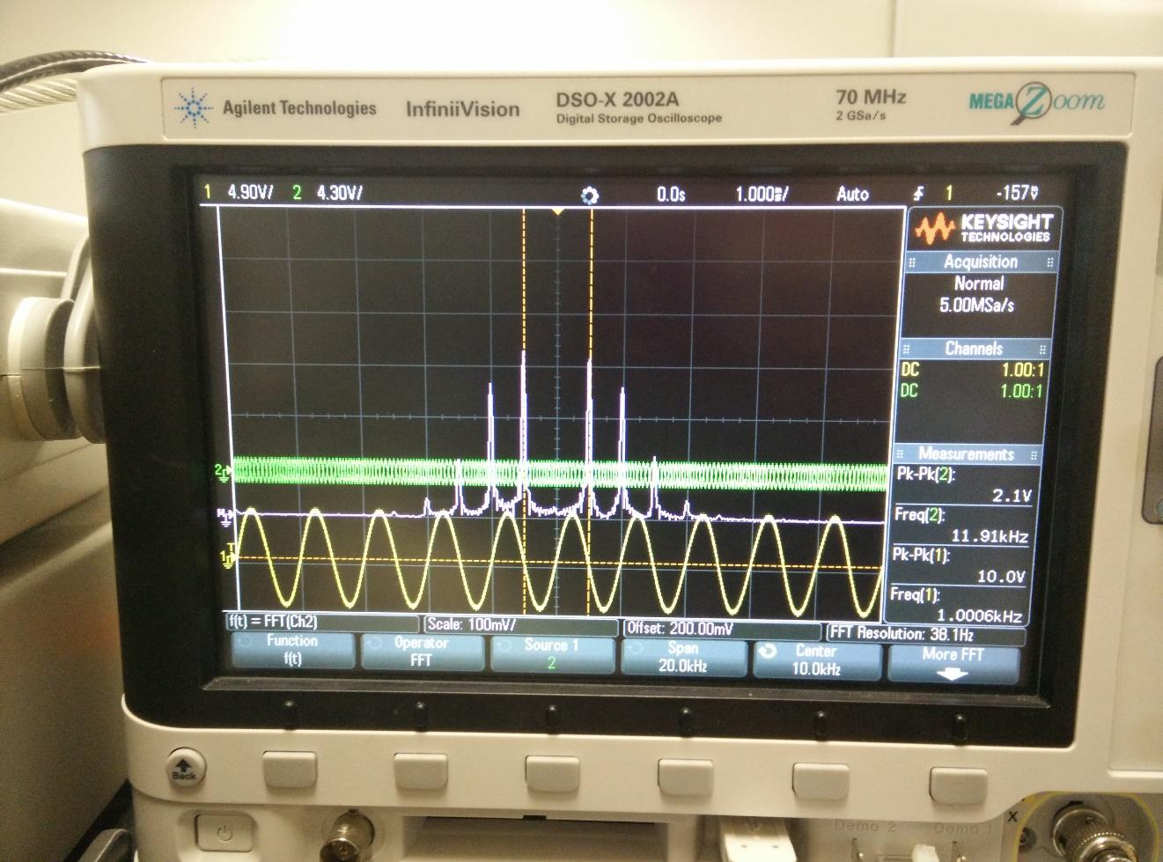

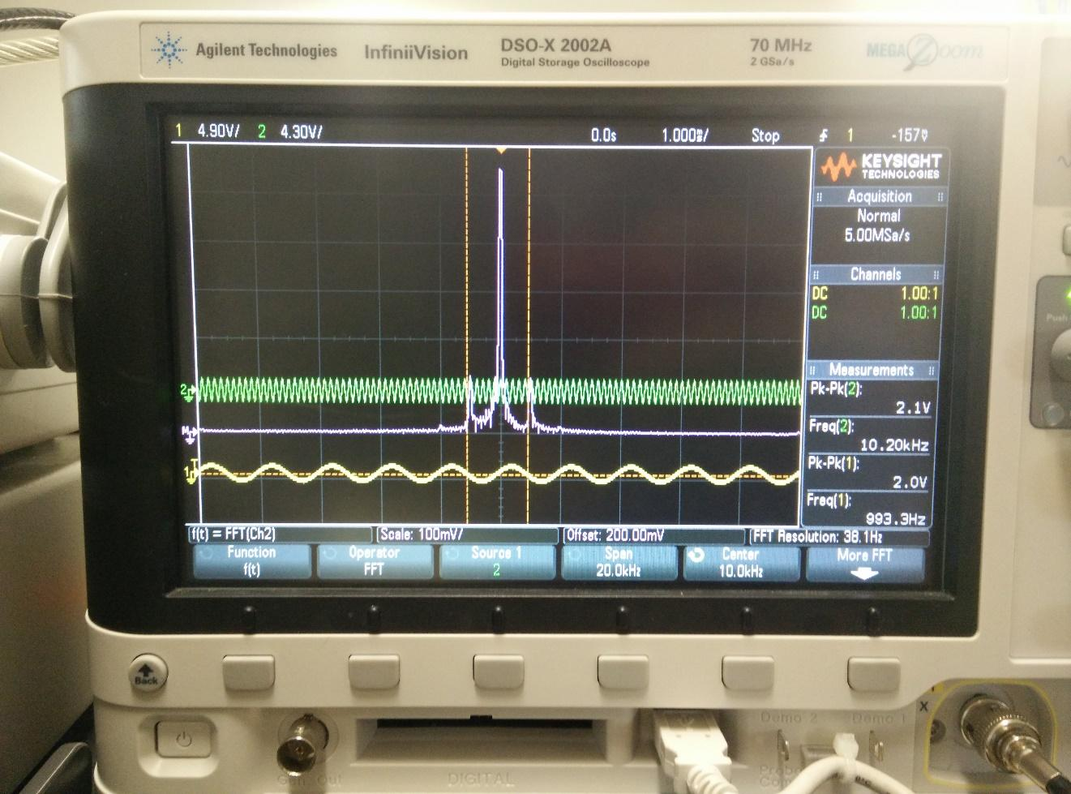**Figure 1:** The result of the oscilloscope for Part A when the amplitude was increased from **2V** to **10 V**. It results in a spectral null in the middle of the spectrum.

**Figure 2.**The oscilloscope’s spectrum of the FM signal when $m\left(t\right)$ is at **2 V** is shown.

It can be said that the decreasing of the amplitude also decreases the bandwidth of the spectrum. It was found that when gradually decreasing frequency of $m\left(t\right)$ from **1 kHz to 100 Hz**, the bandwidth of the spectrum decreased. However, when $β$ is increased, it results in more harmonics.

When $A_{m}$**= 2 Vpp** and $f_{m}$**= 1 kHz**, the resulting one-sided rms spectrum of the FM signal was:

**Table 1:** One Sided RMS with $A_{m}$ **= 2 Vpp** and $f_{m}$ **= 1 kHz**

|  |  |
| --- | --- |
| **One-sided rms Spectrum with $A_{m}$ = 2 Vpp and $f_{m}$ = 1 kHz** | |
| **S** | 284.83 mV |
| **C** | 456.98 mV |

The modulating signal parameters were then changed to $A_{m}$ **= 1 Vpp** and $f_{m}$ **= 500 Hz**,

**Table 2:** One Sided RMS with $A_{m}$ **= 1 Vpp** and $f_{m}$ **= 500 Hz**

|  |  |
| --- | --- |
| **One-sided rms Spectrum with $A_{m}$ = 2 Vpp and $f_{m}$ = 1 kHz** | |
| **S** | 284.83 mV |
| **C** | 456.98 mV |

Part B: Modulation Index

$$β= \frac{K_{f}A_{m}}{2πf_{m}} ⟶ K_{f}= \frac{β2πf_{m}}{A_{m}}$$

The modulating signal $A_{m}≈$ **0 Vpp** and $f_{m}$ **= 1 kHz**, increasing $A_{m}$

**Table 3:** The First Spectral Null

|  |  |
| --- | --- |
| **First Spectral Null** | |
| $f_{c}$ | 1 kHz |
| $$A_{m}$$ | 9.3 V |
| $$K_{f}$$ | 1.587 kHz/V |
| $$β$$ | 2.35 |

Determining $A_{m}$ when $β$ **= 0.2**, **1**, **5** when $f_{m}$ **= 1 kHz** and $K_{f}$ **= 3.45 kHz/V**

$$β= \frac{K_{f}A_{m}}{2πf_{m}} ⟶ A_{m}= \frac{β2πf_{m}}{K_{f}}$$

$$β=0.2 A_{m}= \frac{(0.2)2π(1000 Hz)}{3450 Hz/V}=0.364 V$$

$$β=1 A_{m}= \frac{(1)2π(1000 Hz)}{3450 Hz/V}=1.821 V$$

$$β=5 A_{m}= \frac{(5)2π(1000 Hz)}{3450 Hz/V}=9.106 V$$

One-Sided RMS Spectrum with $β=0.2$, $f_{m}$ **= 1 kHz**, $K_{f}$ **= 3.45 kHz/V**

**Table 4:** Magnitudes of Spectral Components when $β=0.2$

|  |  |
| --- | --- |
| **Magnitudes of Spectral Components** | |
| **Am** | 0.364V |
| **C** | 566.53 mV |
| **S** | 65.73 mV |

One-Sided RMS Spectrum with $β=1$, $f_{m}$ **= 1 kHz**, $K_{f}$ **= 3.45 kHz/V**

**Table 5:** Magnitudes of Spectral Components when $β=1$

|  |  |
| --- | --- |
| **Magnitudes of Spectral Components** | |
| **Am** | 1.821V |
| **C** | 456.98 mV |
| **S** | 281.7 mV |

One-Sided RMS Spectrum with $β=5$, $f_{m}$ **= 1 kHz**, $K_{f}$ = 3.45 kHz/V

**Table 6:** Magnitudes of Spectral Components when $β=5$

|  |  |
| --- | --- |
| **Magnitudes of Spectral Components** | |
| **Am** | 9.106V |
| **C** | 115.81 mV |
| **S** | 200.32 mV |

As shown in the tables above, it can be said that as the $A_{m}$ increases when $β$ increases. It was determined that the carrier’s magnitude decreases and the lower or upper side band’s magnitude increases. For modulation indices that are equal to 0.2, 1, and 5, the RMS values for the FM signal is shown in **Table 7**.

**Table 7:** RMS Values for $β=0.2, 1, \& 5$

|  |  |
| --- | --- |
| **RMS Values for Specific Modulation Indices** | |
| $β$ | **RMS** |
| **0.2** | 0.257 |
| **1** | 1.287 |
| **5** | 6.439 |

**Table 8:** Bandwidth using Carson’s Rule

|  |  |
| --- | --- |
| **Bandwidth for Specific Modulation Indices** | |
| $β$ | **BFM** |
| **0.2** | 4.4 kHz |
| **1** | 6 kHz |
| **5** | 14 kHz |

From Carson’s Rule:

$$B_{FM}=2(∆f+ B_{m})$$

$$f_{m}=1 kHz$$

$$∆f= β x f_{m}$$

$$B_{m}=2 x f_{m}$$

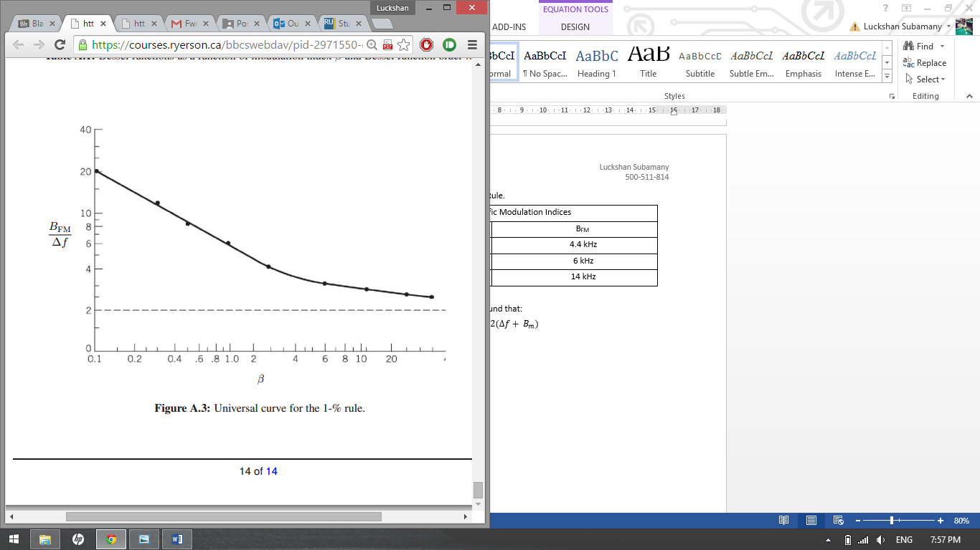

**Figure 3:** Universal Curve for 1% Rule

**Table 9:** Bandwidth using Universal Curve for 1% Rule

|  |  |
| --- | --- |
| **Bandwidth for Specific Modulation Indices** | |
| $$β$$ | **BFM** |
| **0.2** | 2 kHz |
| **1** | 6.5 kHz |
| **5** | 17 kHz |

Part C: Operational Characteristics of Phase = Locked Loop

From the data collected, it was determined that when input signal frequency $f_{i}$ was progressively increasing, the trace of signal suddenly coordinated and remained synchronized at **Ve = 7.866 V** and frequency of **8.5 kHz**.

**Table 10:** PLL Values for Frequency increasing from **4 kHz** with **Vref = 5.545**

|  |  |  |
| --- | --- | --- |
| $$f_{i}$$ | **Ve** | **Phase Angle** |
| **9 kHz** | 7.746 V | 114° |
| **10 kHz** | 7.503 V | 95° |
| **11 kHz** | 7.258 V | 77° |
| **12 kHz** | 7.011 V | 58° |
| **13 kHz** | 6.762 V | 39° |
| **14 kHz** | 6.511 V | 20° |

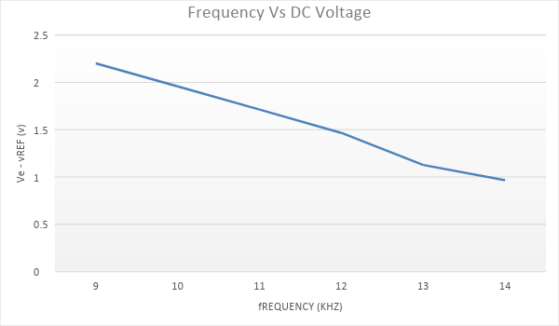

**Figure 4:** Graph of frequency for fi increased from **4 kHz** vs Ve -Vref.

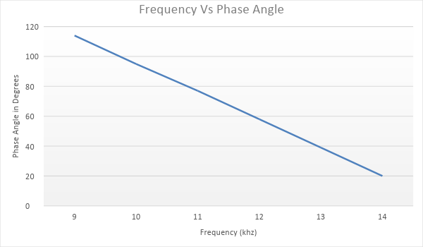

**Figure 5:** Graph displaying frequency for fi increased from **4 kHz** vs Phase Angle

**Table 11:** PLL Values for Frequency decreasing from **16 kHz** with **Vref = 5.545**

|  |  |  |
| --- | --- | --- |
| **Fi** **(kHz)** | **Ve (V)** | **Phase Angle (°)** |
| 12.7 | 6.841 | 45° |
| 11.7 | 7..089 | 62° |
| 10.7 | 7.336 | 82° |
| 9.7 | 7.581 | 101° |
| 8.7 | 7.824 | 120° |
| 7.7 | 8.065 | 138° |
| 6.7 | 8.305 | 156° |

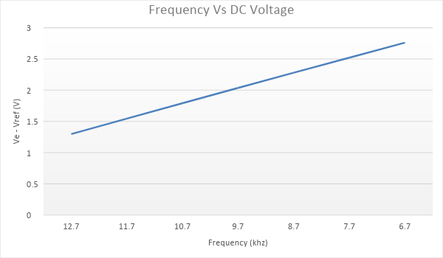

**Figure 6:** Graph of frequency for fi decreased from **16 kHz** vs **Ve-Vref**

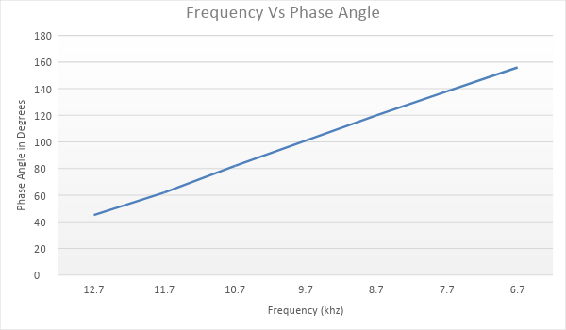

**Figure 7:** Graph of frequency for fi decreased from **16 kHz** vs **Phase Angle**

# **Discussion**

In this lab, it was obvious when the modulating signal varied the instantaneous frequency of carrier wave that resulted in frequency modulation. Through this technique, when the FM signal was generated, and the frequency-domain features were examined.

Based on experimental results that were gained through Steps A.2-A.3, it was clear that when the amplitude of single tone modulated FM signal (Am) increases from 2V to 10V peak-to-peak, the spectrum of FM signals spectral nulls increases, and the bandwidth of the signal also increases. Equally, it was observed that when Am increases causing the height of spectral nulls to decrease. As frequency (Fm) of modulating signal *m(t)* was gradually decreasing from 1kHz to 100Hz, the spectrum of FM signal changed by an increase in spectral nulls, and a decrease in height of spectral nulls. The bandwidth remained the same when decreasing the Fm from 1kHz to 100Hz. Comparing Am to Fm, it was clear that the bandwidth changed proportionally with Am and stayed constant when changing Fm.

If the modulating signal *m(t)* was equal to Amsinωmt and ΦFM(f) is its one-sided rms spectrum, and m’(t) = KAmsinKωmt where K is a positive integer and Φ’FM(f) is its one-sided rms spectrum, it was observed that ΦFM(f) and Φ’FM(f) were identical. Ideally, ΦFM(f) and Φ’FM(f) are equal since they have the same carriers. For example, if KAm = A’m, where Wm = 2πfm, and KWm=W’m it is evident that K values in FM modulation index (β) equation will cancel and result in equal ΦFM(f).

Based on the calculations that were gained through Steps B.1-B.2, β was calculated using Appendix A.1 matching the values taken from the frequency spectrum (J values) along with Am =0; once β was known, the parameter for Kf was investigated using the equation:

$$β=\frac{k_{f}A_{m}}{2πf_{m}}$$

$$k_{f}=\frac{β2πf_{m}}{A_{m}}$$

In this experimentation, it was observed that [ΦFM(f)] rms is the rms value of the FM signal $φ_{FM}\left(t\right)= A_{c}cos⁡(ω_{c}t+βsinω_{m}t)$. According to the measurements that were taken from Steps B.4-B.6 for $β$ equal to 0.2, 1 and 5 the rms value of the FM signal was 0.257, 1.287, and 6.439 respectively. Prelab 3 that was written for this experiment shows the theoretical calculation (Question 1b). Also, **Table 7** refers to RMS values at these modulation indices.

Carson’s rule as well as the 1% rule was used to approximate the bandwidth of FM signal with modulation indices 0.2, 1, and 5. **Table 8** and **Table 9** show the estimated bandwidths for both the Carson’s rule method and the 1% rule method. Carson’s rule allowed us to use Bfm = 2nmax(fm) where the fm was equal to 1kHz to come up with an approximation for the bandwidth. The 1% rule is useful for to use the universal curve represented through **Figure 3** to distinguish the corresponding bandwidths.

**Figure 2** indicates the connection diagram to measure phase-locked loop (PLL) features. When input signal frequency fi was slowly increased, it was noticed that the trace of the signal suddenly matches and remains that way when the DC voltage Ve at the [DEM out] was at 7.866V. The trace was coordinated right after a frequency of 8.5KHz which is known as fP. From the measurements measured in Steps C.2-C.3, **Figures 4** and **5** indicate the Ve-Vref graphed vs fi when increased from 4KHz and the phase Vo (t) and Vi (t) graphed vs frequency for fi when increased from 4KHz. Similarly, for Step C.4, **Figures 6** and **7** show the plot of Ve-Vref vs frequency when fi decreased from 16KHz and the phase between Vo(t) and Vi(t) vs frequency when fi decreased from 16KHz. When fi was slowly increased from 4KHz to fp, fi tends to be less than fp and results in some few isolated narrow-band frequency positions as input and output voltages were corresponding. This fact was due to the frequency change from Channel 1 and Channel 2 of system by the perseverance to become coordinated at that one moment. Also, when frequency is not locked to PLL, the voltages will stay at bias values.

Throughout this experimentation, all the data that was gathered resulted in values that were as expectation. Minor error might have been present throughout this lab; these errors could have been due to the sensitivity of the machinery, or inaccurate cursor measurements for amplitude and the one-sided rms spectrum. For example, the cursor might have been a little bit over or under the tip of the spectral nulls when attempting to get data. Also, when we saw there was extra noises coming from a channel’s signal, it was evident that one of the wires was not connected properly. To acquire accurate results, it was noticed that we had to be more patient while measuring the amplitude or one sided rms spectral with cursors and to connect the wires properly. This will reduce the human errors in this experiment.

# **Conclusion**

Frequency Modulation and Demodulation resulted in accurate data that was precise with the expected relationships. This test allowed us to learn how to connect a FM signal generator, how to connect the system to measure phase-locked loop characteristics and lastly how to connect a system to demodulate FM signals. Furthermore, in this lab, it was recognizable that the relationship between the amplitude of the modulating signal and its bandwidth were proportionally changing (as Am increased BW increased) and when the frequency fm varied the bandwidth stayed constant. Respectively, the modulation indices were investigated in second part of experiment. This allowed us to understand that as the modulation index β increased from 0.2, 1 to 5, the one-sided rms spectrums’ behavior changed. As β increased, the magnitude of the carrier decreased whereas the lower and upper side bands magnitude increased. Similarly, the third part of lab, we detected the features of the phase-locked loop. Overall, this lab was completed with minor sources of error and was overall a successful experiment.

# **References**

Dong, Dong, et al. “Analysis of Phase-Locked Loop Low-Frequency Stability in Three-Phase Grid-Connected Power Converters Considering Impedance Interactions.” *IEEE Transactions on Industrial Electronics*, vol. 62, no. 1, 2015, pp. 310–321., doi:10.1109/TIE.2014.2334665. Accessed 26 Mar. 2019.

Silveri, M. P., et al. “Quantum Systems under Frequency Modulation.” *Reports on Progress in Physics. Physical Society (Great Britain)*, vol. 80, no. 5, 2017, p. 056002., doi:10.1088/1361-6633/aa5170. Accessed 26 Mar. 2019.